Preventing Romani Segregation in the Czech Industrial Badlands
By Jake Bowers

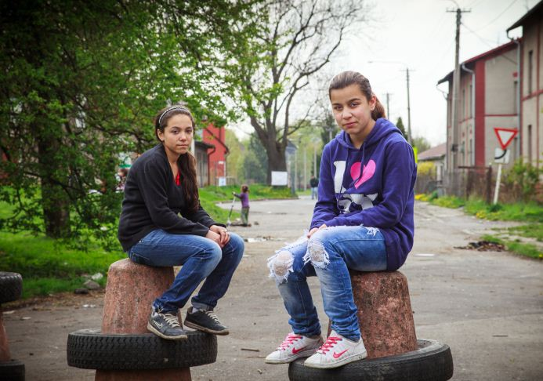
The Czech city of Ostrava is a place where modern Romani history is still being written. This heavy industrial Czech city close to the Polish border is a place where the fall of communism is still taking it’s toll.
Photo Courtesy of Simon Hipkins
Unemployment is high and it’s as high as 60% among the substantial Romani community that originally came to work in the shadow of the city’s steel mills. The ill treatment of the Romani community here, from the forced sterilisation of local Romani women to the practice of segregating Romani children into special schools, has often made Ostrava the ugly poster child of Europe’s enduring and intractable anti-Romani apartheid. But if the city has bad form, it’s also home to a whole load of Romani feistiness that has led to the Romani community’s battle for civil rights ending up in court.
In a momentous decision for Roma across Europe, the European Court of Human Rights ruled on 14 November 2007 that segregating Roma students into special schools was a form of unlawful discrimination.
In the case of D.H. and Others v. the Czech Republic the court found that the rights of 18 Romani school children from Ostrava to education and a life free from racial discrimination had been breached. For the first time, those who sought legal redress for the practice - widespread in Central and Eastern Europe - of shunting Romani students, regardless of their intellectual abilities, into "special" schools for children with learning disabilities had been succesful. Research by the European Roma Rights Center (ERRC) used in the case showed that Romani students in the city of Ostrava were 27 times more likely than similarly situated non-Roma to be placed in special schools and that over half of the population in remedial special schools was Romani.
But on the fifth anniversary of the decision in November 2012, the community took to the streets not to celebrate but to protest. "We've gathered on the fifth anniversary of the verdict issued by the European Court of Human Rights, which said the segregation of Romani children and their sending to special schools is unlawful," said Jolana Smarhovycova, the protest's organiser.
"Some legislative changes have been made, but the approach to Romani kids remains unchanged,“ said Smarhovycova. Research by civil society organisations into the National Roma Integration Strategy in the Czech Republic in 2012 supports the demonstrators view. They established that 32 to 35% of all children in Czech special schools are Romani and that the proportion of Roma is still 5 to 10 times higher than in the overall population.
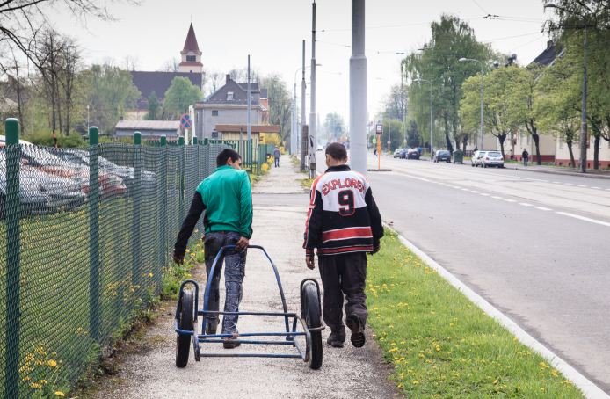
So how can it be that a relatively wealthy country at the heart of Europe can still practice such a blatant form of educational apartheid five years after it was shamed for doing so in the European Court of Human Rights? Like many problems the reasons are complex but also very simple.
Photo Courtesy of Simon Hipkins
“The situation of insufficient early years education is so crucial for Roma kids and their parents,” says Markéta Kráčalíková, Inclusive Education Program Coordinator at the Open Society Fund Prague.
“Where is the difference between Czech kids and Roma kids when it comes to early years? Even Czech kids don’t have places in the state kindergarten and they can’t rely entirely on private nurseries which are subsidised by the town and region. The main reason is little money or difficulties with money management, as well as the different approach to raising children which does not meet the requirements of school institutions.”
But there is also a problem even more fundamental than poverty, that no amount of money will ever address and its institutional racism. Placing Romani kids in special schools is entirely legitimate in the Czech Republic with or without a diagnosis or misdiagnosis. Romani kids are simply judged to be mentally inferior to their Czech counterparts by the Czech authorities because of who they are.
Filip Rames, Fighting Discrimination and Inclusive Education Program Manager of the Open Society Fund Prague, agrees with demonstrators. “Despite the legal success, little has changed,” he says bluntly. But rather than taking to the streets or the courts, he’s involved in funding three projects in and around Ostrava that have innovative solutions to the problem of Romani kids being sent to special schools.
Filip explains that the all important assessment that determines which school a Romani child is sent to may well be blighted by institutional racism, but it is also affected by the pre-school experience of Romani children. “These children often speak Slovak and Romani as first languages, but they then have to take the test using bad Czech. So we’ve found it’s crucial to work with the children to avoid this, so that they can succeed in any test.” In essence, they’ve found that the best way to avoid Romani kids being segregated in school is to work with their parents at a preschool age, so they can do just as well as their Czech classmates. Think of it as an educational inoculation against segregation.
Filip explains that due to the termination of preschools in the 1990s, affordable preschool education is generally unavailable in the Czech Republic which has a massive impact on Romani families.
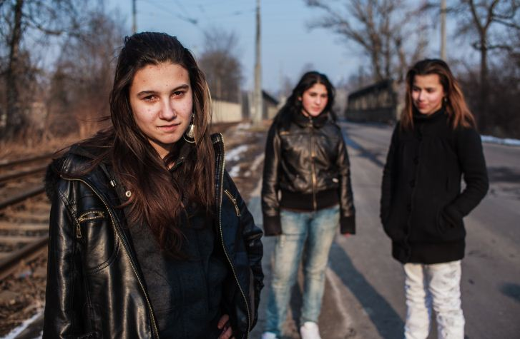
“One possible solution is through supporting parental competencies in families with small children in parental centres. These efforts can lead to a gradual elimination of the preliminary disadvantage resulting from life in social and economic exclusion. In the case of Roma families, it is also possible to build on the existence of strong family ties and backgrounds, which then can simply be reinforced by educational activities between parents and children,” says Filip.
Photo Courtesy of Simon Hipkins
So the big idea for challenging discrimination against the Romani community is as brilliant as it is simple, and it borrows a long held principle of good health, which is that it is always far easier to prevent a problem than to actually cure it.
So the Open Society Foundation’s Early Childhood Program, in cooperation with the OSF Prague foundation, has supported seven projects across the Czech Republic aimed at improving the early care of Roma children from socially excluded localities.
When I catch up with Social Worker Vera Dolakova she’s on the street on her way back to Jekhetane children’s centre in the predominantly Roma neighbourhood of Privoz in Ostrava. Jekhetane is a amalgam of the Romani words ‘one’ and ‘together’, a literal unification of two words which symbolises the unity that’s so badly needed between Czechs and Romanies. Her clients live in extremely poor housing which is often overcrowded and lacking electricity. Hygiene is often bad and the community has high levels of hepatitis.
“We deliver early years education in two ways,” she says. “In our centre, and in the homes of the families themselves. We have activities for kids and their parents from the age of 3 to 6. We teach parenting skills to the parents and we teach the kids how to do things and how to learn.” So far about 25 or 30 families have benefitted from the work, many of them with more than one child.
That’s a great start I say, but shouldn’t the state be helping these kids? “Of course,” she laughs, “but that’s not where the politics here are at. The politicians just want to remove people from the districts.” Like politicians across Europe and the centuries, the elected members of Ostrava have opted for the seemingly easy option of displacing problems rather than dealing with them. As the Roma residents of Prednadrazi Street in the city found out when they resisted unlawful evictions last summer.
Despite its modest impact and recent beginnings, Vera says her work is popular with the Roma community. “They really like to come to our centre,” she says. “The kids love it because there’s equipment here they can use and they get bored at home. But some mothers can’t come to our centre because their kids are dirty or they simply don’t have the ability to get here.”
Like all of those delivering early years education to Romani kids across Europe, Vera is passionate about its potential.
“I think it’s crucial,” she says, “because if you can work with these small kids, if you can teach them how to behave and prepare them for school, the only thing that will be different about them when they get there will be the colour of their skin.” She pauses and considers that in the racially charged atmosphere of the Czech Republic that may not be enough.
But if she’s right the politicians will have started to finally run out of excuses.

